Unit 1 Transformations
Definitions
Transformations: It is a change that occurs that _________ or _____________________ in a specific ______________ onto an image. These are ____________________, ______________________, ___________________, ___________________.
__________________: The position of the shape ___________ the change is made.
_________________: The position of the shape ______________ the change is made.
Reflections:
Translations:
Rotations:
Dilations:

Translations
If a point is moved “a” units to the ____________ and “b” units _____________, then the translated point will be at _________________
If a point is moved “a” units to the________________ and “b” units ________________, then the translated point will be at ________________
Image A translates to image B by moving to the right 3 units and down 8 units.
A (2, 5) _________________________________________
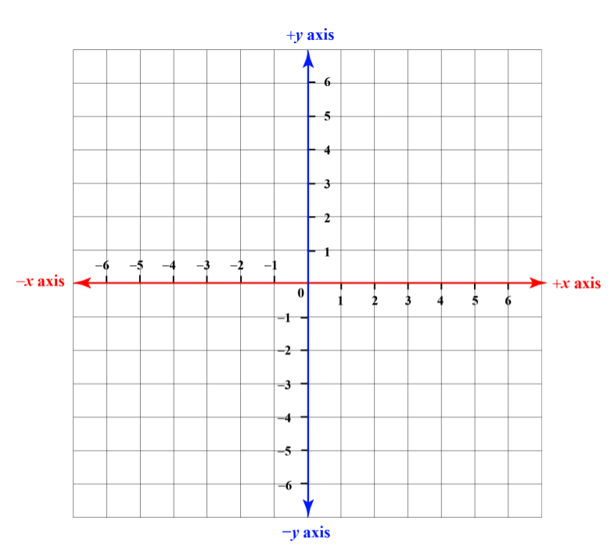
Vector Notation ___________________________________________
Practice:

Translation:

Pre-image-

Image-
Translation:

Pre-image-

Image-

Translation:

Pre-image-

Image-

